1. Leaving the table, unnoticed: mountain yellow-legged frog extinctions have weak effects on resources, competitors, and communities
2. Weak responses of resources and competitors to removal of endangered mountain yellow-legged frog tadpoles
3. Weak responses of resources and competitors to loss of endangered mountain yellow-legged frog tadpoles
4. Weak interactions between algae, mayflies, and tadpoles suggest communities will have weak response to mountain yellow-legged frog extinctions.
5. Weak responses of resources and competitors to loss of an endangered amphibian
6. Weak top-down and competitive effects of an endangered amphibian
7. Weak interactions between algae, mayflies, and endangered tadpoles
8. Herbivory and competitive effects of mountain yellow-legged frog tadpoles: extinctions may have weak effects on communities
9. Ecological roles of endangered Mountain yellow-legged frog tadpoles

Thomas C. Smith†, Marina Bozinovic, Yishen Miao, Cherie J. Briggs

Department of Ecology, Evolution, and Marine Biology, University of California, Santa Barbara, California 93106 USA; phone: (805) 893-2888

†email: thomas.smith@lifesci.ucsb.edu

Author Contributions: Thomas C. Smith conceived the study, performed the research and analysis, and wrote the manuscript; Marina Bozinovic and Yishen Miao contributed to the research, analysis, and text, and edited the manuscript; Cherie J. Briggs contributed to study design, data analysis, and edited the manuscript.

Abstract

Worldwide declines of amphibian populations and loss of amphibian biodiversity have prompted investigations into the ecological functions of endangered and declining amphibian species and the consequences of their extinctions. In the Sierra Nevada of California, mountain yellow-legged frogs are nearly extinct, yet their interactions with other species, remain largely unquantified. We performed two experiments to quantify top-down control of algae by tadpole grazing, and to quantify competition between tadpoles and mayflies. In field enclosures in two remote high elevation lakes, we manipulated the densities of tadpoles and mayfly nymphs in a response surface design, and replicated the experiment in three two-week blocks. Only mayflies displayed a negative effect on algal abundance. There was no indication that tadpoles experienced any competition, though increasing tadpole density may have facilitated individual tadpole growth. Mayflies however, were subject to both interspecific or intraspecific competition, as they declined in size as densities of both consumers increased. To test the effects of consumers on algal abundance independent of within lake variability, we performed a mesocosm experiment in which we manipulated the presence and absence of high densities of tadpoles and mayflies. Tadpole presence reduced algal abundance by about 50%, but did not reduce algal growth rate. Mayflies reduced algal abundance when tadpoles were present. Extinctions of endangered mountain yellow-legged frog tadpoles may allow benthic producers to reach higher abundance and biomass, which could influence other consumers in lake communities.

Keywords: *Ameletus spp,* amphibian declines, *Callibaetis ferrugineus*, interspecific competition, *Rana muscosa, Rana sierrae,* response surface design, Sierra Nevada, top-down control

Introduction

Amphibians are declining in diversity and abundance worldwide (Stuart et al. 2004, Wake and Vredenburg 2008). These declines and extinctions of populations and species have the potential to alter the communities in which amphibians live (Paine 1966, Chalcraft and Resetarits 2003, Gruner et al. 2008, Dunne and Williams 2009, Connelly et al. 2014). One of the most direct ways in which amphibian declines will influence communities is in the loss of consumer biomass, potentially leading to release of top-down control of resources (Hairston et al. 1960, Carpenter et al. 1985) or to competitive release for consumers which share those resources (Holbrook and Schmitt 1995). The extent to which an amphibian affects its community by resource consumption may vary depending on the extent to which its resources are subject to top-down control (Shurin et al. 2002, Borer et al. 2005, Wollrab et al. 2012), its ability to reduce resource abundance, and the dependence of potential competitors on shared resources (Murdoch et al. 2003). These characteristics of consumers and communities probably vary greatly among the species within the class Amphibia (Duellman and Trueb 1994, Alford 1999) and between the communities to which those species belong. Therefore, predictions about the ecological effects of any one amphibian species’ decline or extinction, aside from those of the entire class, should be based on quantitative descriptions of its unique interactions and specific effects on its community.

Among amphibian declines, those of the anurans – the frogs and toads – may be the best understood and the most extensive; many anuran populations and species have been dramatically reduced in abundance or driven extinct by habitat destruction, over-exploitation, disease, or a combination of causes (Stuart et al. 2004). These declines have the potential to affect communities and ecosystems; anurans, and especially their tadpoles, can be ecologically important in their respective communities (Alford 1999). Many tadpoles are benthic grazers, and reduce the abundance of benthic producers (Kupferberg 1997a, 1997b, Alford 1999, Connelly et al. 2008, 2014). Tadpoles have been reported reducing algal abundance 60-98% in experiments (Brönmark et al. 1991, Lamberti et al. 1992), and have been observed facilitating changes in natural stream community composition by reducing algal abundance (Kupferberg 1997a).This ability to control resources means that tadpoles also have the potential to be strong exploitative competitors. When tadpoles graze down algae, they can induce declines in abundance, growth, and fecundity of other amphibian, vertebrate, insect, and invertebrate grazers (Brönmark et al. 1991, Kupferberg 1997a, 1997b). The ecological interactions between tadpoles, their resources and other consumers are not limited to top down and exploitative interactions. Tadpoles can also compete by interference of feeding by other amphibians (Steinwascher 1978) and by aquatic insects (Kiffney and Richardson 2001), can be on the losing side of interspecific competition (Morin et al. 1988) and predation (Pilliod 2002), and can also facilitate other grazers by uncovering grazable benthic material through bioturbation (Ranvestel et al. 2004).

This evidence highlights how tadpoles can shape communities, and thus, the extent to which their loss from a community may affect other species. Like many tadpoles, those of the endangered Mountain yellow-legged frogs (*Rana muscosa* and *R. sierrae*) of California’s Sierra Nevada mountains are grazers of benthic algae, and are potential competitors with mayfly nymphs, caddisfly larvae, diptera larvae, and other benthic macroinvertebrates (Grinnell and Storer 1924, Zweifel 1955, Finlay and Vredenburg 2007). They fill ecological roles the loss of which could alter whole lake communities. These tadpoles may also have been ecologically important because of their historical ubiquity and abundance (Grinnell and Storer 1924). In lakes along both sides of the Sierra Nevada mountains and in streams in the Transverse Ranges of southern California (Vredenburg et al. 2007), tadpoles formerly reached densities of 60 individuals per meter of shoreline (Roland A. Knapp, personal communication) – because of their large size, if all the tadpoles lay “shoulder to shoulder”, they could occupy the entire shoreline. Dramatic declines in the range and abundance of frogs and tadpoles were driven initially by predation by stocked non-native trout (Knapp and Matthews 2000). Despite the cessation of stocking, populations continue to be threatened by the emergence and spread of the amphibian chytrid fungus, *Batrachochytrium dendrobatidis* (Briggs et al. 2005). Now, large populations are limited to a handful of extremely high elevation lakes in Yosemite and Sequoia/Kings Canyon National Parks and the adjacent John Muir Wilderness in the southern Sierra. In most lakes in the Sierra Nevada, mountain yellow-legged frogs and tadpoles have gone locally extinct (Briggs et al. 2010, Vredenburg et al. 2010)..

To explore how these declines and local extinctions might affect Sierra Nevada lake communities, our objective was to quantify tadpoles’ impacts on their resources and on potential competitors. In Sierra Nevada lakes, tadpoles ingest algae (epilithon largely composed of diatoms, some cyanobacteria, green algae, chrysophytes, and other microbes). We chose to study mayfly nymphs as potential competitors because they can also suppress algal abundance (Hill and Knight 1987, Morin et al. 1988, Dudley 1992, Hertonsson et al. 2007) and are abundant in Sierra Nevada lakes (Bradford et al. 1998, Epanchin et al. 2009). We predicted that in the absence of tadpoles, algal abundance would be highest, and that increasing densities of tadpoles would reduce algal abundance. In addition, mayflies would also reduce algal abundance, and tadpoles and mayflies together would reduce algal abundance additionally. We also predicted that average body sizes of each consumer would decline along with increasing consumer densities. To investigate these predictions, we performed an *in situ* field enclosure experiment and a mesocosm experiment, which simulated simplified communities in which tadpoles were removed or were at lower than historic densities. The results of these experiments clarify the role of mountain yellow-legged frog tadpoles in Sierra Nevada lakes, and sheds light on how their extinctions might affect these lake communities.

Methods

Experimental methods

We performed two experiments, a field experiment and a mesocosm experiment. Our field experiment allowed us to describe, within the natural setting of two remote high elevation lakes, the interactions between two consumers: tadpoles (*Rana muscosa* and *Rana sierrae*) and mayfly nymphs (Ephemeroptera, *Callibaetis ferrugineus* and *Ameletus spp.*), and their shared resource, benthic organic matter. This consists largely of diatoms but can also include green algae, cyanobacteria, chrysophytes, detritus, bacteria and other microbes; because of the dominance of diatoms and producers, we refer to it hereafter as algae. In the mesocosm experiment, we tested the effects of the same grazers (*Rana sierrae* and *Callibaetis ferrugineus*) on algal resources, in artificial habitats which eliminated the natural nutrient, temperature, and substrate heterogeneity found within most lakes.

*Field enclosure experiment. –* In the field enclosure experiment, we used a response surface design (Inouye 2001) to characterize the independent and interactive effects of grazers. Response surface designs facilitate description of intra- and interspecific interactions, as they allow two factors to vary alone and together. For each of our two consumers, we established four treatment levels, including the absence of and three density levels of each, the highest of which was set by the highest densities of these two consumers we have observed in amphibian surveys and invertebrate community surveys (Roland A. Knapp, personal communication, and Smith et al., in review). Tadpole treatment levels were 0, 2, 10, and 20 individuals, while mayfly treatment levels were 0, 25, 125, and 250 individual mayflies. Each treatment was a combination of two of these treatment levels, and was replicated once in each of two lakes, except the zero-tadpole/zero-mayfly treatment which was replicated twice in each lake (total n = 34). Because we could not replicate treatments physically, we replicated the experiment in time in three blocks.

The two study lakes were remote high elevation lakes in the Kings Canyon National Park backcountry, referred to as LeConte (3221 m elevation, 37°06'58.78" N 118°38'40.16" W) and Spur (48 km to the southeast of LeConte, 3518 m elevation, 36°43'47.49" N 118°23'38.33" W, Google Earth 2014). Both lakes lie close to and west of the Sierra Nevada crest. They are small alpine lakes, however while LeConte is surrounded by small meadows, white bark pine and willow, talus, and bare bedrock, Spur is in a basin devoid of vegetation and is surrounded by mostly talus and minimal bare bedrock. The water in these lakes has low nutrient concentrations and circumneutral pH: nitrate 0 – 10 μmol L-1, total phosphorus 0 – 1 μmol L-1 (Sickman et al. 2003); median pH ≅ 7 (Bradford et al. 1998). We selected these two lakes because both had large, disease free cohorts of mountain yellow-legged frog tadpoles (R.A. Knapp, personal communication) and large mayfly nymph populations, were relatively accessible, and not in areas frequently used by backpackers.

Seventeen enclosures were placed in each lake, along the shoreline in the littoral zone where tadpoles feed during the day. Enclosures were 0.5 m wide x 0.5 m tall at one end and 0.5 m wide x 1.5 m tall at the opposite end, and were 2 m long (1 m2 on the bottom). Each was oriented perpendicular to the shoreline, so that the tall end sat in deep water, and the short end sat along the shoreline (Fig. 1). This wedge shape allowed tadpoles to use deep and shallow water. Enclosures were partially submerged so an air space remained in the top of each enclosure to accommodate emerging mayflies, and one rock from outside the lake was placed inside each enclosure to accommodate metamorphosing tadpoles. Enclosures were supported by a light weight steel frame (Sturdy Stake #ST6 www.homedepot.com) and guy-lines, and were constructed from plastic mesh fabric, with pore size approximately 250 μm (Nitex: e.g. SKU 24-C44 www.wildco.com; polyester organza, various sources). This mesh size prevented escape of mayflies and tadpoles, and prevented invasion by other benthic macroinvertebrates, but allowed movement of water, sediment, phytoplankton, and small zooplankton (mostly Copepoda).

We captured tadpoles and mayflies in each study lake. We captured tadpoles throughout both lakes and after weighing and staging them (Gosner 1960), included those between Gosner stage 26 and 41. In LeConte, tadpoles were *Rana sierrae*; in Spur tadpoles were *Rana muscosa* (Vredenburg et al. 2007). We captured mayflies in the littoral zone of the lakes using benthic sweeps of a standard D-net (mesh size 250 μm), and separated mayflies from other invertebrates in a sorting pan using flexible forceps and a turkey baster. While mayflies were not chosen based on instar, we included only those without wing-pads when possible. In LeConte, mayflies were virtually all *Ameletus spp.*, but in Spur, *Ameletus spp.* and *Callibaetis ferrugineus* were present in equal proportions. When tadpoles were older than stage 38 at one visit, they were removed to prevent metamorphosis prior to the next visit; each removed individual was replaced with a younger tadpole. Similarly, adult mayflies which emerged from the nymph stage were replaced by younger individuals.

Algal growth in each enclosure was measured from unglazed porcelain tiles placed on the bottom of each enclosure (two sets of 12 porcelain tiles, each 2.4 cm x 2.4 cm, 140 cm2 total area per enclosure). To account for potential variation in algal growth due to unquantified within lake variation in nutrient concentrations, temperature, currents, or aspect, we established a no-consumer within-lake-location control for each enclosure by placing a set of tiles in a small bag made of the same mesh as enclosures, and setting it in the littoral zone next to each enclosure (Figure 1). We also recorded substrate type below and light within each enclosure. Substrate was described as percent of the substrate below each enclosure which was composed of silt (defined as particles < 0.5mm, as in Knapp and Matthews 2000). Solar radiation (photosynthetic photon flux) was measured within each enclosure at the water surface using a basic quantum meter (Apogee Instruments, Logan, UT).

Experiments began in the early ice-free season (17 July 2009 in LeConte and 21 July 2009 in Spur), and ran in three blocks, which lasted 16-21 days. At the start of blocks two and three, we completely cleaned tiles, and restocked grazers to their initial treatment densities. At the conclusion of each block, we sampled algal abundance, mayfly nymph abundance, emerged adult mayfly abundance, tadpole abundance, gosner stage, and wet weight. These were used as response variables, or to calculate response variables.

Algae abundance was calculated for each enclosure on each sampling date. We collected algae samples from enclosure tiles and from within-lake-location control tiles, for later determination of ash-free dry mass (AFDM). In the field, algae was scrubbed from tiles using a soft-bristle toothbrush, and suspended in 60 mL of water. Suspended algae were collected on a glass fiber filter with 1.2 μm pore size, using a hand powered vacuum pump. Filters were wrapped in foil and stored in a cool dark place (under a boulder) in the field until they could be frozen in the lab for later processing. Filters were dried at 105 C for at least 24 hours, weighed, combusted at 500 C for 1 hour, then weighed again. Ash-free dry mass was calculated as the difference between filter-plus-sample weights before and after combustion (Hauer and Lamberti 2007). When less than 60 mL of suspension had been filtered, we multiplied the measured AFDM by the fraction of 60 mL that was filtered.

At the conclusion of each block, we counted, weighed, and staged tadpoles. At the conclusion of the entire experiment, all tadpoles were weighed and staged a final time, and released back into the lakes. In order to calculate a Gosner stage-mass regression for tadpoles, we collected, euthanized and preserved in 10% formalin 37 tadpoles from a non-study lake (Marmot Lake, 3590 m elevation, 37°15'36.33" N 118°41'01.38" W). The tadpole samples were collected to serve as a model for ash free dry mass. The lengths of the tadpoles were measured and the gut contents of the tadpoles were removed in order to be inspected. We placed the remains in foil boats and weighed the unit before combustion. The boats were then placed in a drying oven set at 105° C for 24 hours. After that period, we reweighed the boats and placed them in a combustion oven at 500° C for one hour.  Once the samples were weighed in their boats, we discarded of the remains and weighed the foil boats by themselves. When we subtracted this weight from the unit, we were able to measure AFDM for each specimen, which was calculated to the nearest 0.1 mg.

The ADFM values from the non-experimental tadpoles from the field were used in conjunction with the lengths of the tadpoles to construct a linear regression with a best fit line. Thirty ADFM values from the tadpoles were graphed against their respective Gosner stages to produce a length-mass relationship. The line best fit to describe the data was a power function that showed an upward trend. We then applied this function to a set of Gosner stages in order to output a set of predicted ADFM values. These values, based on the power function, were associated with Gosner stages of tadpoles taken from the field. The corresponding predicted AFDM was used to find means and standard deviations of each lake from each date.

At the conclusion of each block, we counted mayfly nymphs, and counted and collected emerged adult mayflies. At the conclusion of the entire experiment, all mayflies were collected and preserved. We measured nymph to the nearest 0.1 mm under 10 x magnification, using graticules in the eyepieces of a stereoscope ([insert model info here]); we did not simultaneously quantify instars of individuals. To calculate a length-mass regression relationship for mayflies, we collected a sample of mayflies from each lake. These mayfly nymphs were preserved in ethanol, then measured, dried at 105 C for 24 hours, weighed, combusted at 500 C for 1 hour, and weighed again; ash free dry mass was calculated as the difference between the two weights (Hauer and Lamberti 2007). Ash free dry mass was calculated as it was for algal samples.

We plotted non-experimental tadpole and mayfly AFDM data with respect to tadpole Gosner stage or mayfly length, and fit regression lines to these data (e.g. Sabo et al. 2013). To estimate experimental tadpole and tadpole and mayfly biomasses from the easily measured stage or length, we used the formulae of the size-AFDM regression lines to calculate estimated AFDM of each individual experimental tadpole and mayfly.

*Mesocosm experiment. –* We also conducted a mesocosm experiment to further explore the effects of tadpoles and mayflies on algal resources, without the environmental variability that occurs throughout lakes. We used a 2 x 2 factorial design, with treatment levels for presence and absence of tadpoles and mayflies, arranged randomly among four blocks. Four mesocosms contained zero consumers, four contained16 tadpoles, four contained 250 mayflies, and the remaining four contained 16 tadpoles and 250 mayflies (n = 16).

Mesocosms were located at the Sierra Nevada Aquatic Research Laboratory near Mammoth Lakes, CA (2165 m elevation, 37°36'50.83" N 118°49'57.56" W). We used sixteen cube shaped (1 m3) concrete tanks lined with Thoroseal concrete sealer, with sloping, partially submerged shelves on the south facing side to allow tadpoles and metamorphs to bask (Fig.1). These tanks were filled with water from adjacent Convict Creek; nitrate and phosphate levels in Convict Creek are similar to those observed in most Sierra Nevada lakes, and while pH is higher than most Sierra Nevada lakes (pH 7.9 – 8.5) it is in the range tolerate by mayflies and tadpoles in lakes (pH 6.5 – 8.5) (LELAND et al. 1989, Bradford et al. 1998, Sickman et al. 2003). Creek water was the source for algae, and mesocosms were filled in April 2010 to allow algae communities to develop prior to the introduction of consumers. Each mesocosm contained thirty sets of twelve porcelain tiles (similar to those used in the field enclosures, each tile was 2.4 cm x 2.4 cm, total area of 12 tiles x 30 sets of tiles: 2074 cm2) to provide standard surfaces on which we could measure algal abundance; twenty five were placed on the bottom of each mesocosm, and five were placed on each shelf (Fig. 1).

We collected 160 *Rana sierrae* tadpoles (Gosner stages 34-39) from Marmot Lake (John Muir Wilderness, 3590 m elevation, 37°15'36.33" N 118°41'01.38" W) and transported them in one gallon containers with portable aerators and surrounded by blocks of snow. About 3000 mayflies (*Callibaetis ferrugineus*) were collected from a small pond in Yosemite National Park (2608 m elevation, 37°53'07.18" N 119°23'39.97" W) using a D-net with 250 μm mesh size, sorted using 250 μm sieves, pipettes, and turkey basters, and transported similarly to tadpoles.

The experiment began in late July 2010 when we added consumers to the mesocosms. We were not able to maintain the mayfly densities, because mayflies were surprisingly undetectable in the mesocosms, and therefore experienced high mortality without our knowledge. Tadpole density was maintained by adding younger tadpoles to replace individuals which metamorphosed and were removed. We ended the experiment when so many tadpoles metamorphosed that we could no longer maintain tadpole densities in the mesocosms. We then measured size (tail width, and body length not including tail length) and developmental stage (Gosner stage) of at least 10 tadpoles from each mesocosm. We sampled each mesocosm for mayflies using the same D-net used to collect them, sampling until 10 consecutive sweeps collected no more mayfly nymphs. Mayflies were counted, but not measured.

In the mesocosm experiment, we sampled algal abundance four times: once prior to the start of the experiment in July, then three more times during July and August 2010. On each date, we sampled bottom tiles and shelf tiles. Tiles on the bottoms of mesocosms were exposed to grazing for one, two, and three weeks; in week 1, 15 tiles were removed from mesocosms, sampled for algae, and replaced. In week 2, five previously sampled tiles were removed, sampled again, and replaced. In week 3, at the end of the experiment, all remaining tiles were removed and sampled. Four out of five tiles on the shelves were sampled on the first and second date and replaced; all five were sampled at the end of the experiment. For all tiles, we scrubbed algae from each tile, suspended it in 60 mL of water, and filtered the suspension onto a glass fiber filter, using an electric vacuum pump. These samples were frozen immediately, and later processed for AFDM as described above. When less than 60 mL of suspension were filtered, we multiplied the AFDM by the fraction of 60 mL that was filtered.

Analytical methods

*Analysis of field enclosure experiment. –* For our analysis of field enclosure algal abundance data, we used two sets of independent variables in alternative analyses. In the first analysis the two independent variables were the categorical variables mayfly density and tadpole density, with four levels for each density treatment of each consumer. We also included categorical covariates for experimental block, with three levels, and for lake, with two levels (LeConte and Spur). The lake covariate accounted for differences between lakes such as elevation, temperature, or size. We also included continuous covariates for duration of experimental block (days), solar radiation within enclosures, and substrates beneath enclosures.

Alternatively, instead of using the categorical variables for mayfly and tadpole density, we used total biomass estimated for each consumer within each enclosure. For mayflies, per-enclosure AFDM was the sum of estimated individual AFDM calculated from the lengths of mayflies and the length-mass regression relationship. For tadpoles, per-enclosure total AFDM was based on the Gosner stage-mass relationship and stages we observed for each tadpole. These consumer biomasses were used as continuous independent variables in our second analyses, with the same covariates described above.

Our response variable of interest was algal abundance (algae AFDM m-2), measured at the conclusion of each block. We used linear mixed effects models (Zuur et al. 2009) to test the effect of consumer density and consumer biomass on algal biomass, with the response variable algal abundance, predictor variables tadpole and mayfly abundance or biomass, and covariates siltiness, radiation, duration of block, lake, and block. We included an interaction term between consumers, because of the potential for tadpoles to either facilitate or interfere with mayfly grazing. To meet the assumption of normality of residuals (Zuur et al. 2009), we log transformed algal biomass. We compared models that included random intercepts (for block and for lake), random slopes for consumer effects in different lakes, and allowed variance to differ among experimental blocks, lakes, and levels of mayfly and tadpole density (Zuur et al. 2009). To account for within lake variability in algal abundance, we calculated a second response variable, by subtracting algal abundance in enclosures from the algal abundance on within-lake-location control tiles (e.g. AFDMLocation Control – AFDMEnclosure), and we repeated the analyses.

To examine the effect of intraspecific or interspecific or competition on mayfly size, we fit the average length of mayflies at the end of the last block, to generalized least squares models in order to determine the factors to which mayfly body length responds. These models included tadpole density, mayfly density, block, a lake and mayfly species interaction, and allowed the variance of mayfly length to differ across the gradient of tadpole density and between mayfly species.

We analyzed tadpole biomass, using per-enclosure average predicted AFDM, to indicate intraspecific and interspecific competition. Our linear model included tadpole density, mayfly density, lake, block, and a tadpole density x lake interaction. We included this interaction because preliminary plots suggested that the slopes of the relationship between tadpole biomass and density differed in each lake. The model also allowed for random intercepts and difference variances in tadpole biomass for each block.We tested for normality of residuals of models of tadpole biomass data using a Shapiro-Wilk normality test, and examinedit graphically to determine normality.  We also tested for heterogeneity of variance by visually assessing boxplots of residuals with respect to tadpole density, lake, and block. To further explore the interaction between tadpole density and lake, we repeated this analysis of tadpole biomass, but separately for tadpoles from each lake.

*Analysis of mesocosm experiment. –* In our analyses of mesocosm algal abundance, the independent variables were tadpole abundance and mayfly presence;. We included an interaction term between consumers, because of the potential for tadpoles to either facilitate or interfere with mayfly grazing. We used a similar approach to fitting linear models as outlined above. We included covariates for duration of algal growth (days) and for the initial abundance of algae (log AFDM) in each mesocosm. We allowed variance to differ with respect to consumer presence-absence or abundance. We analyzed only tiles from the bottom of the tank. Due to the high mortality of mayflies, we repeated this analysis using final mayfly abundance rather than mayfly presence-absence.

We also calculated the growth rate of algae in the experiment, using the initial July algal abundance from each mesocosm as the time-zero abundance, the measured week 1 or 3 algal abundance as the time-one abundance, and the days between the beginning of the experiment and relevant sample date as the growth period. This growth rate was analyzed using generalized least squares models, similarly to the procedure described above. All analyses were performed using R (The R Foundation for Statistical Computing 2012).

We also analyzed mayfly length as a response to tadpole presence and mayfly presence or final mayfly abundance, in the mesocosms.

Results

*Field enclosure experiment. –* Tadpoles and mayflies had negative, but equivocal effects on the abundance of algae in field enclosures (Figure 2). Effects were more distinct in LeConte; the effects of both consumers were more variable in Spur (Figure 3). The best fit linear model (Table 1) of the raw algal abundance used log-transformed raw algal abundance to meet the assumption of normality of model residuals. The best-fit model included a random intercept for experimental block, which allowed mean algal abundance to differ among blocks; lake, tadpole density, and mayfly density were fixed effects (Table 2). Repeating the analysis using consumer biomasses, rather than densities, produced essentially the same result.

When we analyzed algal abundance controlledfor within-lake variability, only mayflies had a negative effect on algal abundance. The best fit linear mixed effects model of within-lake-variability controlled algal abundance (Table 3) included fixed effects for mayfly density, duration of block, and a random intercept that allowed the controlled algal abundance to differ with respect to experimental block, nested within lake, and allowed variance of controlled algal abundance to differ among experimental blocks and between lakes (Table 4, Figure 4).

Increased tadpole density was associated with higher average individual biomass in LeConte, but was not so in Spur (Figure 6). The best fit linear mixed effect model included an interaction between tadpole density and lake, as well as random intercepts and different variances for sampling blocks (Table 6). Separate linear mixed effect models for each lake clarified the interaction, illustrating that tadpole density enhanced tadpole biomass only in LeConte (Table 7). The coefficient for tadpole density in this model suggests that, in LeConte, 4 tadpoles can increase the biomass of a tadpole by 1 mg. Mayfly density did not affect tadpole biomass.

In the field enclosures, higher tadpole and mayfly densities reduced body length of mayfly nymphs (Figure 5). Tadpole presence reduced mayfly length by 6-17% in *Ameletus spp.* in LeConte, but had no effect on either species in Spur. Higher mayfly density reduced mayfly length by 8-23% for *Ameletus* *spp*. in LeConte, and 8-10% for *C. ferrugineus* Spur. Because of the difference in mayfly species relative abundance in the two lakes, the best fit generalized least squares model included an interaction between lake and mayfly species; this model also allowed for different variances of mayfly length across the gradient of tadpole density and between the two species (Table 5). While mayflies differed in size between LeConte and Spur, this may have been due to differences in phenology; we did not quantify instars of mayfly nymphs, so we cannot address that difference.

*Mesocosm experiment. –* In the 2010 mesocosm experiment, tadpole presence alone reduced algal abundance by 50% (Figure 7). Mayfly presence did not reduce algal abundance, The best-fit model included fixed effects for tadpole presence, duration of growth, and the initial abundance of algae, and allowed variances to differ between tadpole presence-absence (Table 8). Mayfly presence-absence was not included as a fixed effect in this model. We found no difference among growth rates of algae among consumer treatments (ANOVA, F3,28 = 0.0011, p < 1.0) (Figure 8).

In the mesocosms, mayfly nymph abundance declined by 48% – 100% during the experiment. Live mayflies recovered from mesocosms at the conclusion of the experiment were not near metamorphosis (they did not have wingpads), nor were exuvia or emerged adults ever observed. This apparent mortality was independent of coexistence with tadpoles; despite a trend towards larger declines in mayfly abundance in the presence of tadpoles, the difference was not significant (ANOVA, F2,6 = 0.338, p = 0.58). When we represented mayflies in the mesocosms by their final abundance, rather than presence-absence, the presence of tadpoles affected the outcome: algal abundance increased weakly with mayfly abundance in the absence of tadpoles, but, algal abundance declined with mayfly abundance in the presence of tadpoles (Figure 7). The best fit model of algal abundance, with respect to tadpole presence-absence and mayfly abundance, included fixed effects for a tadpole-mayfly interaction, duration of algal growth, and initial algal abundance, and allowed the variance of algal abundance to differ with tadpole presence-absence (Table 9). .

Discussion

Overall, we found strong effects to no effects of mountain yellow-legged frog tadpoles on algal resources and mayfly competitors (see summary in Table 10). Mountain yellow-legged frog tadpoles can reduce the abundance of algae in mesocosms, however, they had no effect on algal abundance in field enclosures, suggesting that the ability of tadpoles to exert top-down control of algal abundance can be obscured by within-lake variability in algal abundance. Tadpoles appeared to compete with mayfly nymphs, as suggested by reduced average size of individual mayfly nymphs at higher tadpole density in the field enclosures. On the other hand, tadpoles appeared to facilitate mayfly feeding in the mesocosms, as mayflies only had a negative effect on algal abundance when tadpoles were present. Tadpoles may also facilitate their own growth, as we observed that average tadpole biomass was higher at high tadpole density. These endangered tadpoles appear to have some, but not overwhelming, capacity to function as grazers, competitors and facilitators.

The mixed results of our two experiments highlights how environmental variation might weaken species interactions in communities (Chesson 2000), or, at least our ability to detect the consequences of those interactions. The top-down grazing pressure exerted by tadpoles or mayflies was less clear in the field enclosure experiment than in the mesocosm experiment, because noise in the trends of algal abundance with respect to tadpoles and mayflies resulted from between and within lake variation. For us, a drawback of using a response surface design in an environment where spatial replication was not possible was that we had less replication of treatments to account for these natural within-lake variations between each enclosure, and . This highlights how abiotic processes can influence how we perceive the strength of species interactions.

Our contradictory results in field and mesocosm experiments may represent the role that environmental variation plays in interpreting species interactions. Many experiments have concluded that tadpole grazing can reduce algal resources (e.g. Brönmark et al. 1991, Kupferberg 1997a, Alford 1999). However control of algae by aquatic grazers appears to be a general experimental result: in a meta-analysis of grazing experiments, 70% of experiments found that grazers at ambient densities reduced algal biomass (Feminella and Hawkins 1995). Grazer effects were largest in long lab experiments and were smaller for short experiments or field experiments (Feminella and Hawkins 1995). Our results match that conclusion: in our field and mesocosm experiments of about the same duration, tadpoles had no effect in the field enclosures and a strong effect in the mesocosms. We are not alone in reporting a lack of effect of tadpoles in field experiments; in Pacific northwest streams, tailed frog tadpole exclusions did not strongly enhance algal abundance, probably because the effects of tadpole exclusion were masked by between stream variability (Lamberti et al. 1992). Nonetheless, manipulative and natural field experiments have detected regulation of algal abundance by tadpoles, and tadpole exclusion or disease-caused extinctions released algae from top-down regulation. The exclusion of tadpoles from the benthos in neotropical streams resulted in 111% to 200% increases in algal abundance (Ranvestel et al. 2004, Connelly et al. 2008), and after the amphibian chytrid fungus caused extinction of tadpoles in these same streams, algal abundance rapidly increased 2-6 fold (Connelly et al. 2008, 2014). This contradiction between the effects of mountain yellow-legged frog tadpoles and tailed frog tadpoles versus the tropical stream tadpoles reinforces our suggestion that the ecological effects of amphibian declines will vary for each threatened species.

In some cases, top-down processes may play a less important role than bottom-up processes in determining resource abundance, and grazers or predators may do little to limit the abundance of their resource (Power 1992). Consumer control of resources can be weakened by intraspecific competition, if reproduction occurs long after consumption of the resource or if resources are inedible (Power 1992). These cases could apply to tadpoles, which engage in intraspecific exploitative and interference competition (Steinwascher 1978), and for which the time between grazing and reproduction could be years – mountain yellow-legged frog individuals may spend 3 years as a tadpole and then not reproduce until they are 5 or more years old. Effectiveness of tadpole grazing can also be reduced due to the nature or their food: benthic producers like diatoms can pass through animal guts unharmed (PETERSON 1987). In northern Sierra Nevada streams, foothill yellow-legged frog tadpoles don’t assimilate energy from some diatoms, despite grazing on them (Furey et al. 2014). In the feces of our mesocosm tadpoles, diatoms appeared generally intact, many still containing chloroplasts, and the feces of wild caught tadpoles is similar but additionally can contain high proportion of sand, which could reduce feeding efficiency and disconnect tadpole feeding from producer abundance. Furthermore large tadpoles, like those of mountain yellow legged frogs, assimilate a smaller fraction of their food than small tadpoles (Altig McDearman 1975). In some streams in the Pacific Northwest, the presence of grazing tailed frog tadpoles was the major determinant of algal abundance, but the availability of light, a bottom-up process, was more important in other streams (Mallory and Richardson 2005). These findings may clarify reasons behind the limited ability of tadpoles to exert top-down control of algal abundance in Sierra Nevada lakes.

Differences in consumer body size at different intra- or interspecific densities can be used as an indicator of competition, in part because changes in resource availability can affect consumer body size (de Roos and Persson 2013). In our study, we saw that despite little apparent response of presumably shared resource to consumer density, mayflies were largest at lower tadpole densities. This result may be evidence of interspecific competition between tadpoles and mayflies, and it suggests that the loss of mountain yellow-legged frog tadpoles from Sierra Nevada lakes might lead to competitive release (Schmitt and Holbrook 1990, Holbrook and Schmitt 1995) of mayflies, via freed algal resources. Other aquatic insect grazers have shown similar responses to the removal of tadpoles; mayfly and chironomid abundances increased 60% and 20% despite the removal of tailed frog tadpoles having no impact on algal abundance (Kiffney and Richardson 2001).

Despite some evidence for competition between tadpoles and mayflies, we found some evidence that mountain yellow-legged frog tadpoles may facilitate mayflies, as mayflies in our mesocosm experiments only reduced algal abundance in the presence of tadpoles. Tadpoles can benefit their neighbors by bioturbating silt that covers algae, leading to higher abundances of mayfly nymphs in the presence of tadpoles. This has been documented in tropical streams where tadpole bioturbation exposes algal resource which mayflies can use, and mayflies decreased when tadpoles were excluded from patches of the stream bottom (Ranvestal et al 2004). Nitrogen excretion by tadpoles may also enhance algal growth or diversity (Seale 1980, Vanni et al. 2002), which could then subsidize growth by insect grazers or by tadpoles themselves.

Mountain yellow-legged frog tadpoles, as grazers and as competitors, appear to have weak overall effects on their communities. This suggests that their ongoing extinctions may have little impact on Sierra Nevada lake communities. Not all species have strong interspecific interactions (McCann et al. 1998), so extinctions need not always be expected to dramatically reshape whole communities. On the other hand, some suggest that with regards to extinctions, the loss of top-down or negative interactions will alter communities less than the loss of bottom-up or other positive interactions (). Schooling behavior by tadpoles can create patches where dissolved nitrogen is orders of magnitude higher than in adjacent patches without tadpoles (Smith, unpublished data). In nitrogen limited Sierra Nevada lakes (Sickman et al. 2003) this nitrogen subsidy could have a positive effect on algal abundance and diversity. Mountain yellow-legged frog tadpoles are prey that feed adult frogs and draw predators like Clark’s nutcrackers to lake shores to feed (personal observation); Clark’s nutcrackers are essential to the germination of white bark pine (Pilliod 2002), a common high elevation tree in the southern Sierra Nevada (Arno and Hoff 1989).

So, while tadpoles may not strongly effect their communities via grazing, they interact with their communities in other ways that merit investigation. Quantifying the role of tadpoles as grazers is part of the process of describing the community level consequences of mountain yellow legged frog extinctions. Despite any lack of cascading ecological responses to their extinctions, the loss of mountain yellow legged frogs is intrinsically a dramatic change to Sierra Nevada lake communities. The absence of strong top-down or competitive effects by tadpoles does nothing to minimize the fact that these species may soon be extinct.

Literature Cited

Alford, R. A. 1999. Ecology: resource use, competition, and predation. Tadpoles: The Biology of Anuran Larvae:240–278.

Arno, S. F., and R. J. Hoff. 1989. Silvics of whitebark pine (Pinus albicaulis). United States Department of Agriculture, Forest Service General Te.

Borer, E. T., E. W. Seabloom, J. B. Shurin, K. E. Anderson, C. A. Blanchette, B. Broitman, S. D. Cooper, and B. S. Halpern. 2005. What determines the strength of a trophic cascade? Ecology 86:528–537.

Bradford, D. F., S. D. Cooper, T. M. Jenkins Jr, K. Kratz, O. Sarnelle, and A. D. Brown. 1998. Influences of natural acidity and introduced fish on faunal assemblages in California alpine lakes. Canadian Journal of Fisheries and Aquatic Sciences 55:2478–2491.

Briggs, C. J., R. A. Knapp, and V. T. Vredenburg. 2010. Enzootic and epizootic dynamics of the chytrid fungal pathogen of amphibians. Proceedings of the National Academy of Sciences 107:9695 –9700.

Briggs, C. J., V. T. Vredenburg, R. A. Knapp, and L. J. Rachowicz. 2005. Investigating the population-level effects of chytridiomycosis: An emerging infectious disease of amphibians. Ecology 86:3149–3159.

Brönmark, C., S. D. Rundle, and A. Erlandsson. 1991. Interactions between freshwater snails and tadpoles: competition and facilitation. Oecologia 87:8–18.

Carpenter, S. R., J. F. Kitchell, and J. R. Hodgson. 1985. Cascading trophic interactions and lake productivity. Bioscience 35:634–639.

Chalcraft, D. R., and W. J. Resetarits. 2003. Predator identity and ecological impacts: functional redundancy or fuctional diversity? Ecology 84:2407–2418.

Chesson, P. 2000. Mechanisms of maintenance of species diversity. Annual Review of Ecology and Systematics:343–366.

Connelly, S., C. M. Pringle, T. Barnum, M. Hunte-Brown, S. Kilham, M. R. Whiles, K. R. Lips, C. Colón-Gaud, and R. Brenes. 2014. Initial versus longer-term effects of tadpole declines on algae in a Neotropical stream. Freshwater Biology 59:1113–1122.

Connelly, S., C. M. Pringle, R. J. Bixby, R. Brenes, M. R. Whiles, K. R. Lips, S. Kilham, and A. D. Huryn. 2008. Changes in Stream Primary Producer Communities Resulting from Large-Scale Catastrophic Amphibian Declines: Can Small-Scale Experiments Predict Effects of Tadpole Loss? Ecosystems 11:1262–1276.

Dudley, T. L. 1992. Beneficial effects of herbivores on stream macroalgae via epiphyte removal. Oikos 65:121–127.

Duellman, W. E., and L. Trueb. 1994. Biology of amphibians. Johns Hopkins Univ Pr.

Dunne, J. A., and R. J. Williams. 2009. Cascading extinctions and community collapse in model food webs. Philosophical transactions of the Royal Society of London. Series B, Biological sciences 364:1711–23.

Epanchin, P., R. Knapp, and S. Lawler. 2009. Nonnative trout impact an alpine-nesting bird by altering aquatic insect subsidies. Ecology.

Finlay, J. C., and V. T. Vredenburg. 2007. Introduced trout sever trophic connections in watersheds: Consequences for a declining amphibian. Ecology 88:2187–2198.

Furey, P. C., S. J. Kupferberg, and A. J. Lind. 2014. The perils of unpalatable periphyton: Didymosphenia and other mucilaginous stalked diatoms as food for tadpoles. Diatom Research 29:267–280.

Google Earth. 2014. ThomasCSmith_LeConteSpur_map.kmz. https://github.com/TomCSmith/manuscript-support-files/blob/master/ThomasCSmith_LeConteSpur_map.kmz.

Gosner, K. L. 1960. A simplified table for staging anuran embryos and larvae with notes on identification. Herpetologica 16:183–190.

Grinnell, J., and T. I. Storer. 1924. Animal Life in the Yosemite: An Account of the Mammals, Birds, Reptiles, and Amphibians in a Cross-section of the Sierra Nevada. University of California Press.

Gruner, D. S., J. E. Smith, E. W. Seabloom, S. A. Sandin, J. T. Ngai, H. Hillebrand, W. S. Harpole, J. J. Elser, E. E. Cleland, M. E. S. Bracken, E. T. Borer, and B. M. Bolker. 2008. A cross-system synthesis of consumer and nutrient resource control on producer biomass. Ecology Letters 11:740–755.

Hairston, N. G., F. E. Smith, and L. B. Slobodkin. 1960. Community Structure, Population Control, and Competition. The American Naturalist 94:421.

Hauer, F. R., and G. A. Lamberti. 2007. Methods in stream ecology. Academic Press.

Hertonsson, P., K. Åbjörnsson, and C. Brönmark. 2007. Competition and facilitation within and between a snail and a mayfly larva and the effect on the grazing process. Aquatic Ecology 42:669–677.

Hill, W. R., and A. W. Knight. 1987. Experimental analysis of the grazing interaction between a mayfly and stream algae. Ecology 68:1955–1965.

Holbrook, S. J., and R. J. Schmitt. 1995. Compensation in resource use by foragers released from interspecific competition. Journal of Experimental Marine Biology and Ecology 185:219–233.

Inouye, B. D. 2001. Response surface experimental designs for investigating interspecific competition. Ecology 82:2696–2706.

Kiffney, P. M., and J. S. Richardson. 2001. Interactions among Nutrients, Periphyton, and Invertebrate and Vertebrate (Ascaphus truei) Grazers in Experimental Channels. Copeia 2001:422–429.

Knapp, R. A., and K. R. Matthews. 2000. Non-native fish introductions and the decline of the mountain yellow-legged frog from within protected areas. Conservation Biology 14:428–438.

Kupferberg, S. 1997a. Facilitation of periphyton production by tadpole grazing: functional differences between species. Freshwater Biology 37:427–439.

Kupferberg, S. J. 1997b. The Role of Larval Diet in Anuran Metamorphosis 1. Integrative and Comparative Biology 37:146–159.

Lamberti, G. A., S. V. Gregory, C. P. Hawkins, R. C. Wildman, L. R. Ashkenas, and D. M. DeNicola. 1992. Plant—herbivore interactions in streams near Mount St Helens. Freshwater Biology 27:237–247.

LELAND, H. V., S. V. FEND, T. L. DUDLEY, and J. L. CARTER. 1989. Effects of copper on species composition of benthic insects in a Sierra Nevada, California, stream. Freshwater Biology 21:163–179.

Mallory, M. A., and J. S. Richardson. 2005. Complex interactions of light, nutrients and consumer density in a stream periphyton–grazer (tailed frog tadpoles) system. Journal of Animal Ecology 74:1020–1028.

McCann, K., A. Hastings, and G. R. Huxel. 1998. Weak trophic interactions and the balance of nature. Nature 395:794–798.

Morin, P. J., S. P. Lawler, and E. A. Johnson. 1988. Competition between aquatic insects and vertebrates: interaction strength and higher order interactions. Ecology 69:1401–1409.

Murdoch, W. W., C. J. Briggs, and R. M. Nisbet. 2003. Consumer-resource Dynamics. Princeton University Press.

Paine, R. T. 1966. Food web complexity and species diversity. The American Naturalist 100:65.

PETERSON, C. G. 1987. Gut passage and insect grazer selectivity of lotic diatoms. Freshwater Biology 18:455–460.

Pilliod, D. S. 2002. Clark’s Nutcracker (Nucifraga columbiana) Predation on Tadpoles of the Columbia Spotted Frog (Rana luteiventris). Northwestern Naturalist 83:59–61.

Power, M. E. 1992. Top-down and bottom-up forces in food webs: do plants have primacy. Ecology:733–746.

Ranvestel, A. W., K. R. Lips, C. M. Pringle, M. R. Whiles, and R. J. Bixby. 2004. Neotropical tadpoles influence stream benthos: evidence for the ecological consequences of decline in amphibian populations. Freshwater Biology 49:274–285.

Roos, A. M. de, and L. Persson. 2013. Population and Community Ecology of Ontogenetic Development. Page 552. Princeton University Press.

Sabo, J. L., J. L. Bastow, and M. E. Power. 2013. Length–mass relationships for adult aquatic and terrestrial invertebrates in a California watershed.

Schmitt, R. J., and S. J. Holbrook. 1990. Population Responses of Surfperch Released from Competition. Ecology 71:1653–1665.

Seale, D. B. 1980. Influence of Amphibian Larvae on Primary Production, Nutrient Flux, and Competition in a Pond Ecosystem. Ecology 61:1531–1550.

Shurin, J. B., E. T. Borer, E. W. Seabloom, K. Anderson, C. A. Blanchette, B. Broitman, S. D. Cooper, and B. S. Halpern. 2002. A cross-ecosystem comparison of the strength of trophic cascades. Ecology Letters 5:785–791.

Sickman, J. O., J. M. Melack, and D. W. Clow. 2003. Evidence for nutrient enrichment of high-elevation lakes in the Sierra Nevada, California. Limnology and Oceanography 48:1885–1892.

Steinwascher, K. 1978. Interference and exploitation competition among tadpoles of Rana utricularia. Ecology 59:1039–1046.

Stuart, S. N., J. S. Chanson, N. A. Cox, B. E. Young, A. S. L. Rodrigues, D. L. Fischman, and R. W. Waller. 2004. Status and trends of amphibian declines and extinctions worldwide. Science 306.

The R Foundation for Statistical Computing. 2012. R: A Language and Environment for Statistical Computing. R Foundation for Statistical Computing, Vienna, Austria.

Vanni, M. J., A. S. Flecker, J. M. Hood, and J. L. Headworth. 2002. Stoichiometry of nutrient recycling by vertebrates in a tropical stream: linking species identity and ecosystem processes. Ecology Letters 5:285–293.

Vredenburg, V. T., R. Bingham, R. Knapp, J. A. T. Morgan, C. Moritz, and D. Wake. 2007. Concordant molecular and phenotypic data delineate new taxonomy and conservation priorities for the endangered mountain yellow-legged frog. Journal of Zoology 271:361–374.

Vredenburg, V. T., R. A. Knapp, T. S. Tunstall, and C. J. Briggs. 2010. Dynamics of an emerging disease drive large-scale amphibian population extinctions. Proceedings of the National Academy of Sciences 107:9689 –9694.

Wake, D. B., and V. T. Vredenburg. 2008. Are we in the midst of the sixth mass extinction? A view from the world of amphibians. Proceedings of the National Academy of Sciences 105:11466.

Wollrab, S., S. Diehl, and A. M. De Roos. 2012. Simple rules describe bottom-up and top-down control in food webs with alternative energy pathways. Ecology letters 15:935–46.

Zuur, A. F., E. N. Ieno, N. J. Walker, A. A. Saveliev, and G. M. Smith. 2009. Mixed effects models and extensions in ecology with R. Springer.

Zweifel, R. G. 1955. Ecology, distribution, and systematics of frogs of the Rana boylei group. University of California Press.

Tables

|  |  |  |  |  |
| --- | --- | --- | --- | --- |
| Fixed effects | Response variable transformation | Random effects | Heterogeneity of variances | AIC |
| Tadpole Density x Mayfly Density + Lake +  Days in Block + Silt + Radiation + Block |  |  |  | 452.07 |
| Tadpole Density x Mayfly Density + Lake +  Days in Block + Silt + Radiation + Block | Log transformed |  |  | 327.75 |
| Tadpole Density x Mayfly Density + Lake +  Days in Block + Silt + Radiation | Log transformed | Block |  | 329.5  But residuals more normally distributed |
| Tadpole Density x Mayfly Density +  Days in Block + Silt + Radiation + Block | Log transformed | Lake |  | 334.0 |
| Tadpole Density x Mayfly Density +  Days in Block + Silt + Radiation | Log transformed | Block nested in Lake |  | 335.05 |
| Tadpole Density x Mayfly Density + Lake +  Days in Block + Silt + Radiation | Log transformed | Block | By lake | 300.4  Increases non-normality of residuals |
| Tadpole Density x Mayfly Density + Lake +  Days in Block + Silt + Radiation | Log transformed | Block | By block | 327.5  Increases non-normality of residuals |
| Tadpole Density + Mayfly Density + Lake +  Silt + Radiation | Log transformed | Block |  | 326.8 |
| Tadpole Density + Mayfly Density + Lake | Log transformed | Block |  | 324.9 |

Table 1. Summary of candidate models of raw algal abundance in 2009 field enclosure experiment, using numerical tadpole and mayfly density as the independent variables.

|  |  |  |  |  |
| --- | --- | --- | --- | --- |
|  | Linear model coefficient | t(4, 96) | p-value | Random intercept |
| Tadpole Density | -0.03 ± 0.01 | -1.8 | 0.08 |  |
| Mayfly Density | -0.002 ± 0.001 | -1.3 | 0.19 |  |
| Lake | AFDMSpur 1.1 ± 0.23 > AFDMLeConte | 4.6 | <0.0001 |  |
| Block |  |  |  | Random intercept ~ N(0, 0.022) |

Table 2. Terms of best-fit model of log transformed raw algal abundance in 2009 field enclosure experiment, using numerical tadpole and mayfly density as independent variables.

|  |  |  |  |
| --- | --- | --- | --- |
| Fixed effects | Random effects | Heterogeneity of variances | AIC |
| Tadpole Density x Mayfly Density + Lake + Siltiness + Radiation+No. of Days |  |  | 362.0 |
| Tadpole Density x Mayfly Density + Lake + Siltiness + Radiation + No. of Days | Block |  | 365.7; but reduces correlation between fitted values and residuals, and enhances normality of residuals |
| Tadpole Density x Mayfly Density + Lake + Siltiness + Radiation | Random slope for No. of Days nested within random intercept for Block |  | 370.3 |
| Tadpole Density x Mayfly Density + Lake + Siltiness + Radiation + No. of Days | Block | Lake, Block | 231.0 |
| Mayfly Density + No. of Days | Block | Lake, Block | 225.1 |

Table 3. Models of controlled algal abundance for 2009 field enclosure experiment, using numerical tadpole and mayfly density as the independent variables.

|  |  |  |  |  |  |
| --- | --- | --- | --- | --- | --- |
|  | Linear model coefficient | t(__, 96) | p-value | Random intercept | Combined Variance structure |
| Mayfly Density | -0.0011 | -3.7 | 0.0004 |  |  |
| Duration of Block | -0.07 | -1.2 | 0.22 |  |  |
| Lake |  |  |  |  | σLeConte = 0.332  σSpur = 3.362 |
| Block |  |  |  | Random intercept ~ N(0, 0.482) | σblock 1 ~ N(0, 0.482)  σblock 2 ~ N(0, 0.272)  σblock 3 ~ N(0, 0.222) |

Table 4. Description of best-fit model of within-lake-location controlled algal abundance.

|  |  |  |  |  |
| --- | --- | --- | --- | --- |
|  | Coefficient | t(5, 29) | p-value | Variance |
| Tadpole abundance | -0.01 ± 0.006 | -2.3 | 0.03 | σtadpole = 0 = 1.132  σtadpole = 2 = 0.902  σtadpole = 10 = 1.322  σtadpole = 20 = 0.222 |
| Mayfly abundance | -0.004 ± 0.0006 | -6.6 | <0.0001 |  |
| Mayfly species | -2.9 ± 0.13 | -21.3 | <0.0001 | σ*Callibaetis* = 0.062  σ*Ameletus* = 0.222 |
| Lake | -3.1 ± 0.19 | -16.7 | <0.0001 |  |
| Mayfly species x Lake | 2.9 ± 0.20 | 14.3 | <0.0001 |  |

Table 5. For 2009 field enclosures, summary of best fit model of mayfly length.

|  |  |  |  |  |  |
| --- | --- | --- | --- | --- | --- |
| Term | Coefficient | t(4, 89) | P | Intercept | Variance |
| Tadpole Density | 0.29 ± 0.09 | 3.3 | 0.001 |  |  |
| Lake | 0.92 ± 1.6 | 0.57 | 0.57 |  |  |
| Tadpole Density x Lake | -0.40 ± 0.012 | -3.3 | 0.002 |  |  |
| Experimental Block |  |  |  | ~N(0, 3.82) | σJuly ~N(0, 3.12)  σEarly August ~N(0, 6.82)  σLate August ~N(0, 5.02)  σSeptember ~N(0, 5.02) |

Table 6. Summary of best fit model of tadpole biomass; initial model included tadpole density, mayfly density, lake, and sampling block.

|  |  |  |  |  |  |  |
| --- | --- | --- | --- | --- | --- | --- |
| Lake | Term | Coefficient | t(4, 43) | p | Intercept | Variance |
| LeConte | Tadpole Density | 0.26 ± 0.08 | 3.1 | 0.003 |  |  |
|  | Experimental Block |  |  |  | ~N(0, 2.92) | σJuly ~N(0, 3.62)  σEarly August ~N(0, 5.42)  σLate August ~N(0, 4.42)  σSeptember ~N(0, 4.12) |
| Spur | Tadpole Density | -0.11 ± 0.08 | -1.3 | 0.19 |  |  |
|  | Experimental Block |  |  |  | ~N(0, 4.32) | σJuly ~N(0, 2.52)  σEarly August ~N(0, 8.12)  σLate August ~N(0, 5.52)  σSeptember ~N(0, 5.52) |

Table 7. Summary of best fit model of tadpole biomass in each of the two study lakes, to illustrate the interaction between lake and tadpole density.

|  |  |  |  |  |
| --- | --- | --- | --- | --- |
|  | Linear model coefficient | t(3,32) | p-value | Variance |
| Tadpole | -0.04 ± 0.01 | -2.7 | < 0.01 | σno tadpoles = 0.452  σtadpoles present = 0.772 |
| Duration of algal growth | -0.05 ± 0.02 | 3.4 | 0.002 |  |
| Log(initial algae abundance) | 0.59 ± 0.28 | 2.1 | 0.05 |  |

Table 6. For 2010 mesocosm experiment, ANOVA table for best fit linear mixed-effects model of log(algal abundance), relative to tadpole and mayfly presence-absence, duration of algal growth, and initial log(algal abundance).

|  |  |  |  |  |
| --- | --- | --- | --- | --- |
|  | Linear model coefficient | t(5,26) | p-value | Variance |
| Tadpole Presence | -0.02 ± 0.02 | -1.2 | 0.25 | σno tadpoles = 0.442  σtadpoles present = 0.732 |
| Final Mayfly Abundance | 0.003 ± 0.002 | 1.4 | 0.18 |  |
| Tadpole Presence x Final Mayfly Abundance | 0.05 ± 0.014 | 3.6 | 0.002 |  |
| Duration of algal growth | 0.71 ± 0.28 | 2.5 | 0.02 |  |
| Log(Initial algal abundance) | -0.0008 ± 0.0004 | -2.2 | 0.04 |  |

Table 7. For 2010 mesocosm experiment, best fit linear mixed-effects model of log transformed algal abundance, as a function of tadpole presence-absence, final mayfly abundance, the interaction between consumers, duration of algal growth, and of initial algal abundance.

|  |  |  |
| --- | --- | --- |
| Response | Result | Location |
| Algal abundance in enclosures, with respect to grazer density (F) | Tadpole density marginally reduced algal abundance; mayfly density has no effect | Table 1,2; Fig 2, 3 |
| Algal abundance with respect to grazer biomasses (F) | Tadpole density marginally reduced algal abundance; mayfly density has no effect | Not shown |
| Algal abundance controlled for within-lake variation (F) | Mayfly density reduced algal abundance; duration of experiment had a positive effect. Tadpole density has no effect. | Table 3,4; Fig 4 |
| Mayfly length, with respect to grazer density (F) | Both tadpole and mayfly density reduced mayfly body length. | Table 5; Figure 5 |
| Tadpole biomass , with respect to grazer density (F) | Tadpole density increased tadpole biomass, but only in one lake. Mayflies had no effect. | Table 6, 7; Figure 6 |
| Algal abundance among grazer treatments (M) | Tadpoles reduced algal abundance about 50%; mayfly presence had no effect | Table 8; Figure 7 |
| Algal growth rate among grazer treatments (M) | Algal growth rates did not differ among grazer treatments | Figure 8 |
| Algal abundance, using tadpole presence-absence and mayfly abundance (M) | Mayflies reduced algal abundance, but only when tadpoles were present | Table 9; Figure 9 |

Table 10. Guide to response variables analyzed, summary of results, and location in manuscript. The relevant experiment is indicated with the letter (F) field enclosure experiment in lakes in Kings Canyon National Park or (M) mesocosm experiment at Sierra Nevada Aquatic Research Laboratory.

Figures

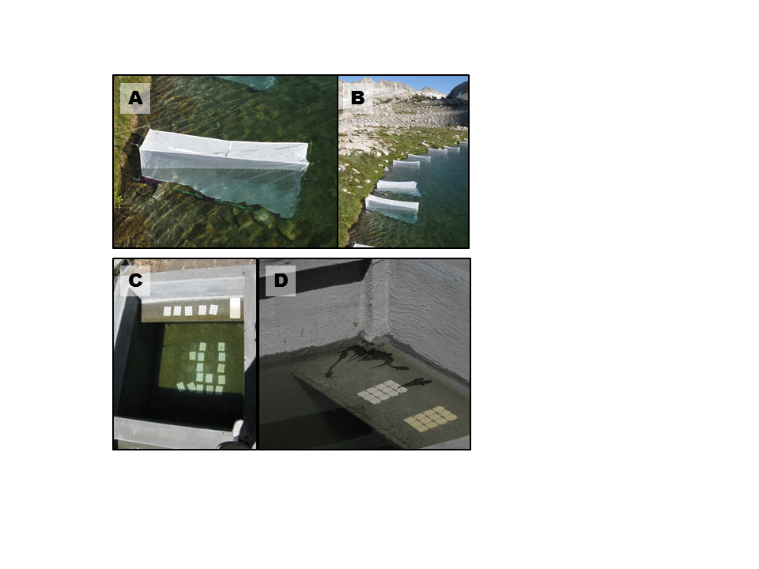

FIG. 1. A and B) Field enclosures in LeConte lake in Kings Canyon National Park, C and D) mesocosms located at Sierra Nevada Aquatic Research Laboratory in Mammoth Lakes, CA.

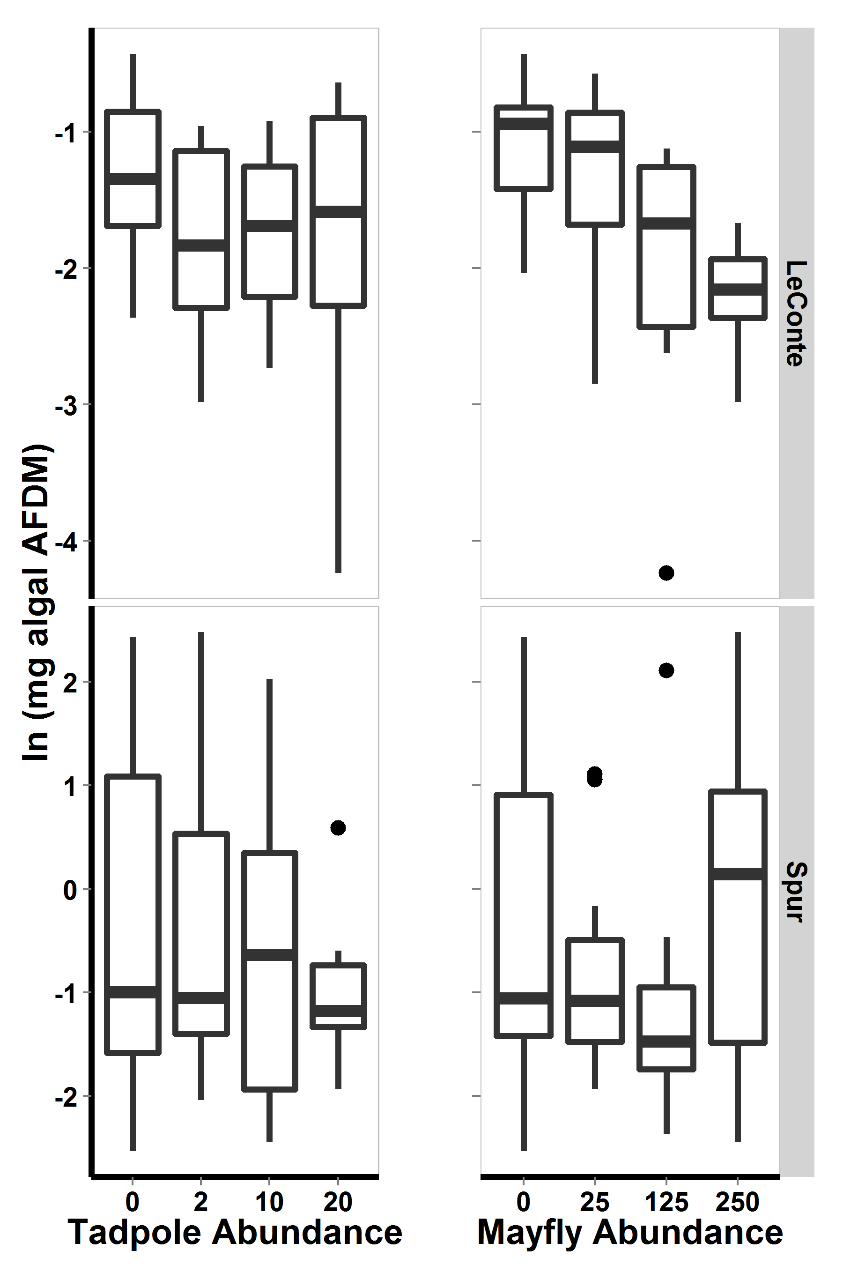

Figure 2. For 2009 field enclosure experiment, algal abundance with respect to lake and to each consumer. Bars show medians, boxes include 50% of the data, and whiskers include 95% of the data.

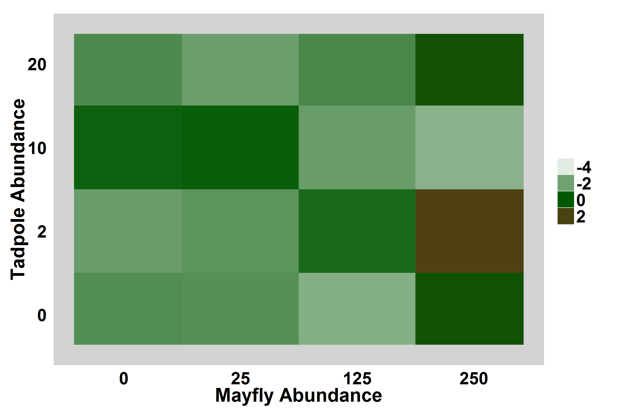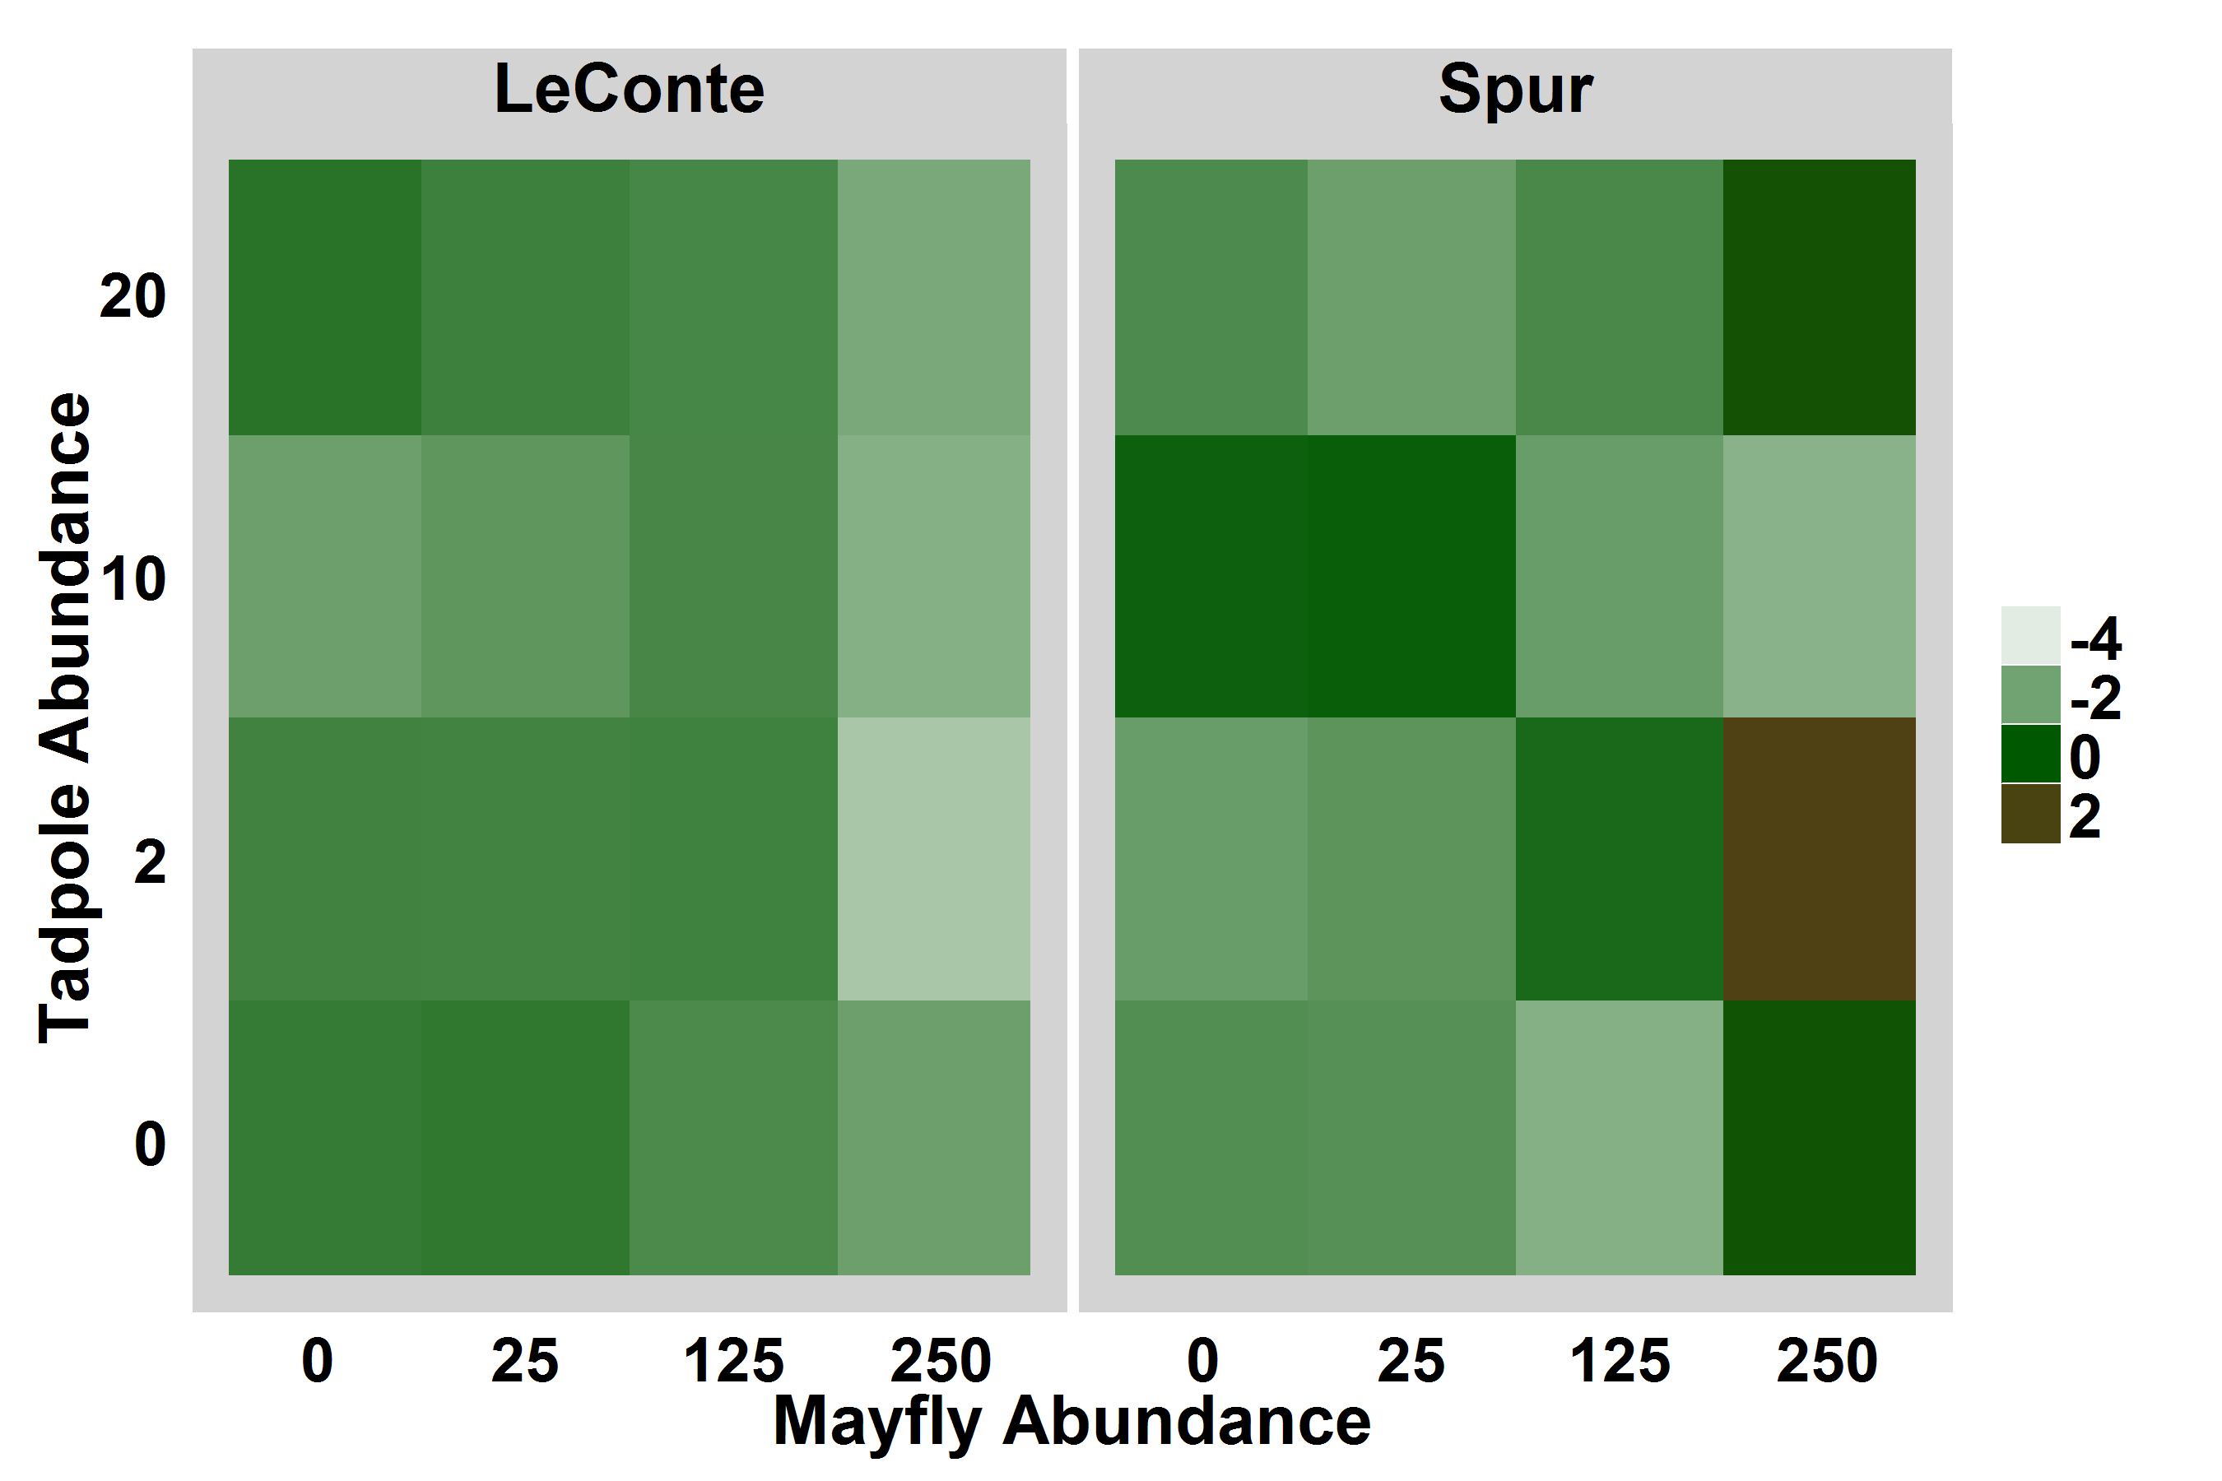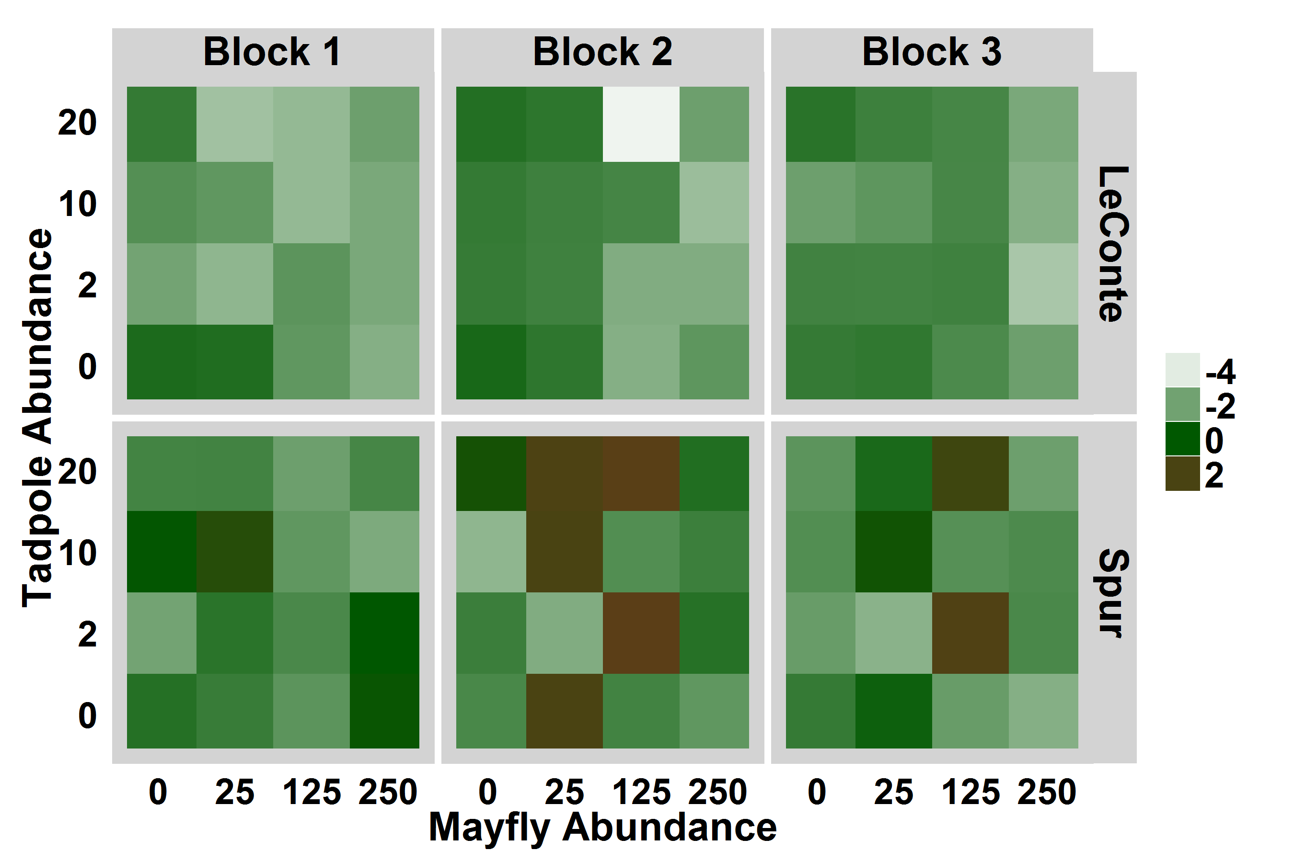

Figure 3. For 2009 field enclosure experiment, heat map displaying log-transformed algal abundance with respect to consumer densities and lake, averaged over experimental blocks. Brown indicates high algal abundance.

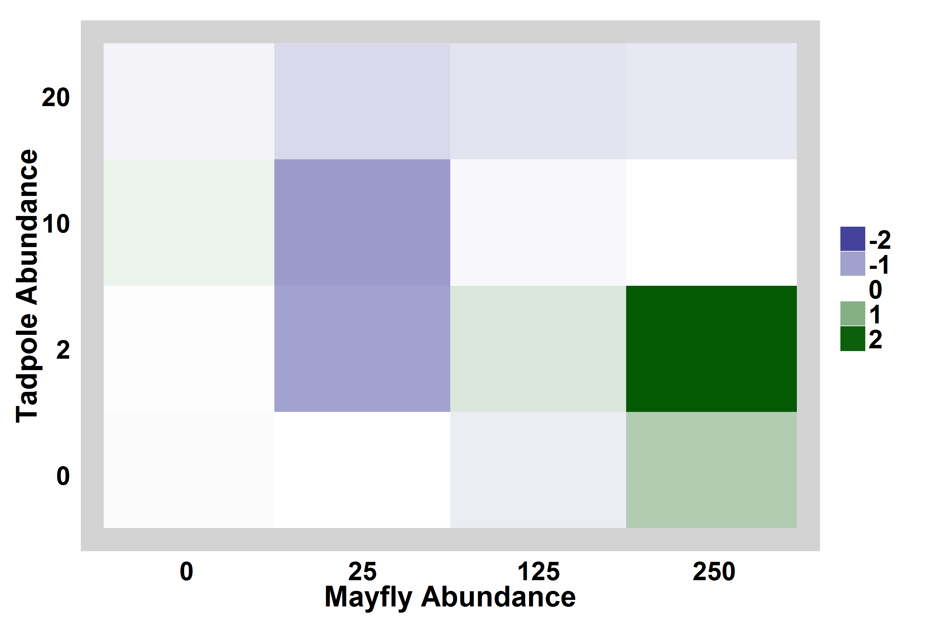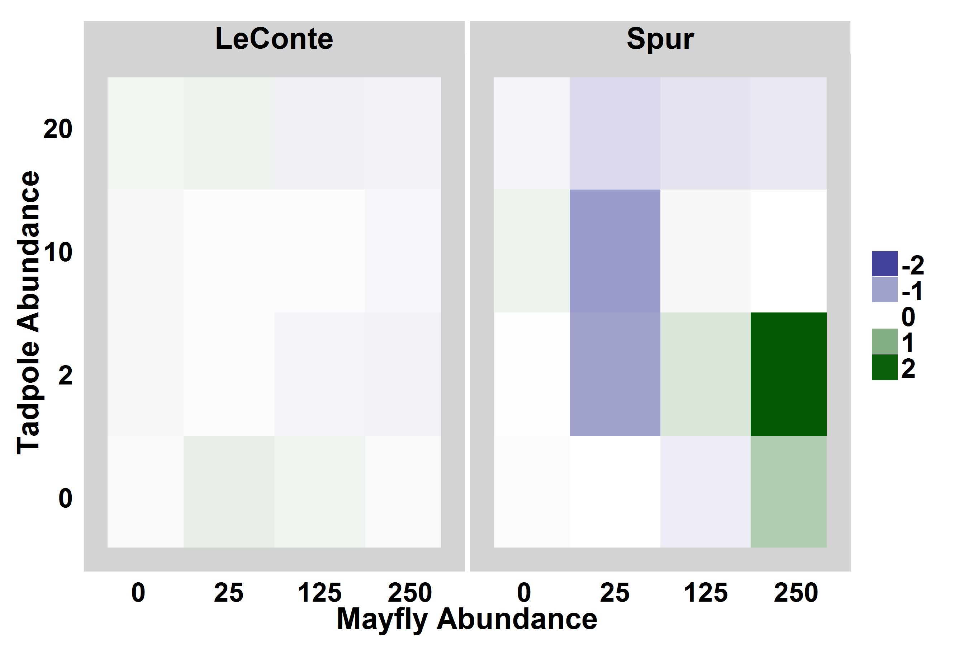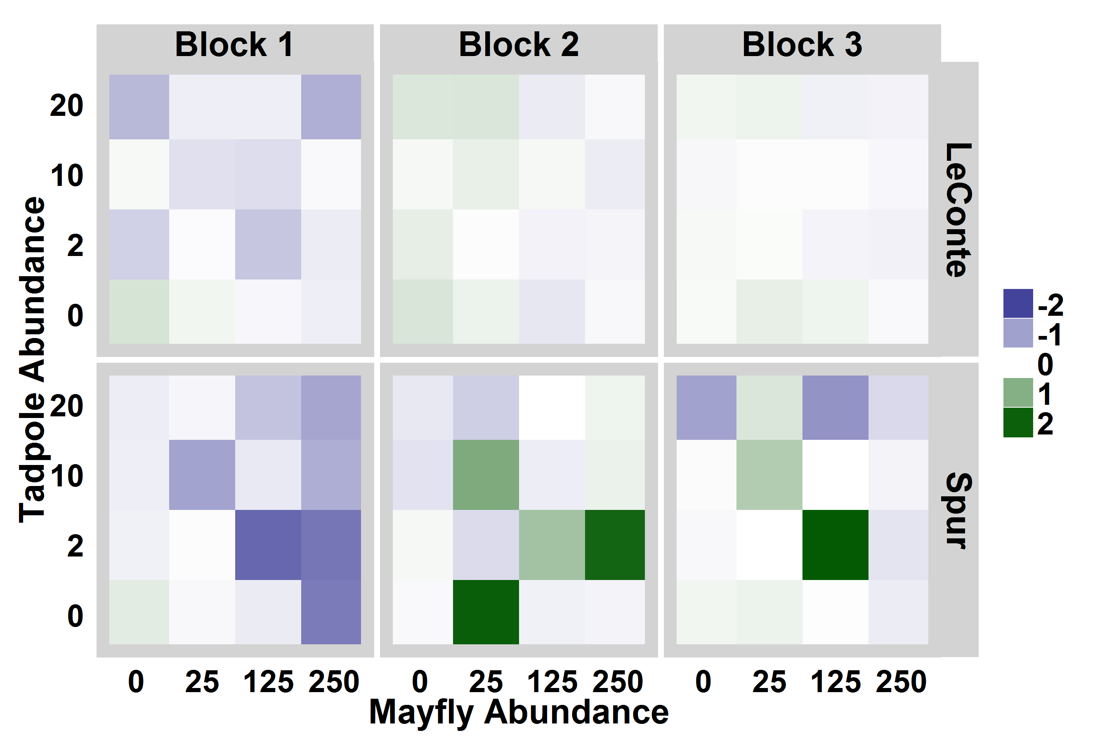

Figure 4. Heat maps showing algal abundance in each enclosure relative to within-lake-location controls. Bluer colors indicate that algal abundance was lower in the enclosure than in the control, i.e. consumers reduced algal abundance, while greener colors indicate that algal abundance was high in enclosures relative to controls. For display purposes, the relative algal abundance was log-modulus transformed.

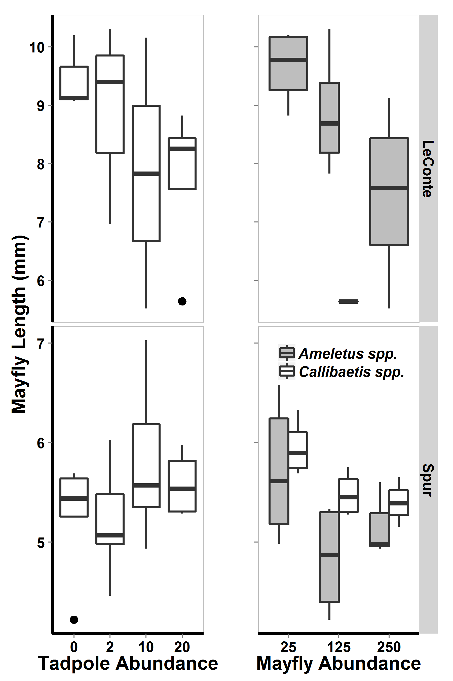

Figure 5. For 2009 field enclosures, mayfly lengths (mm) with respect to tadpole density and to mayfly density. Note difference in mayfly length scales between lakes.

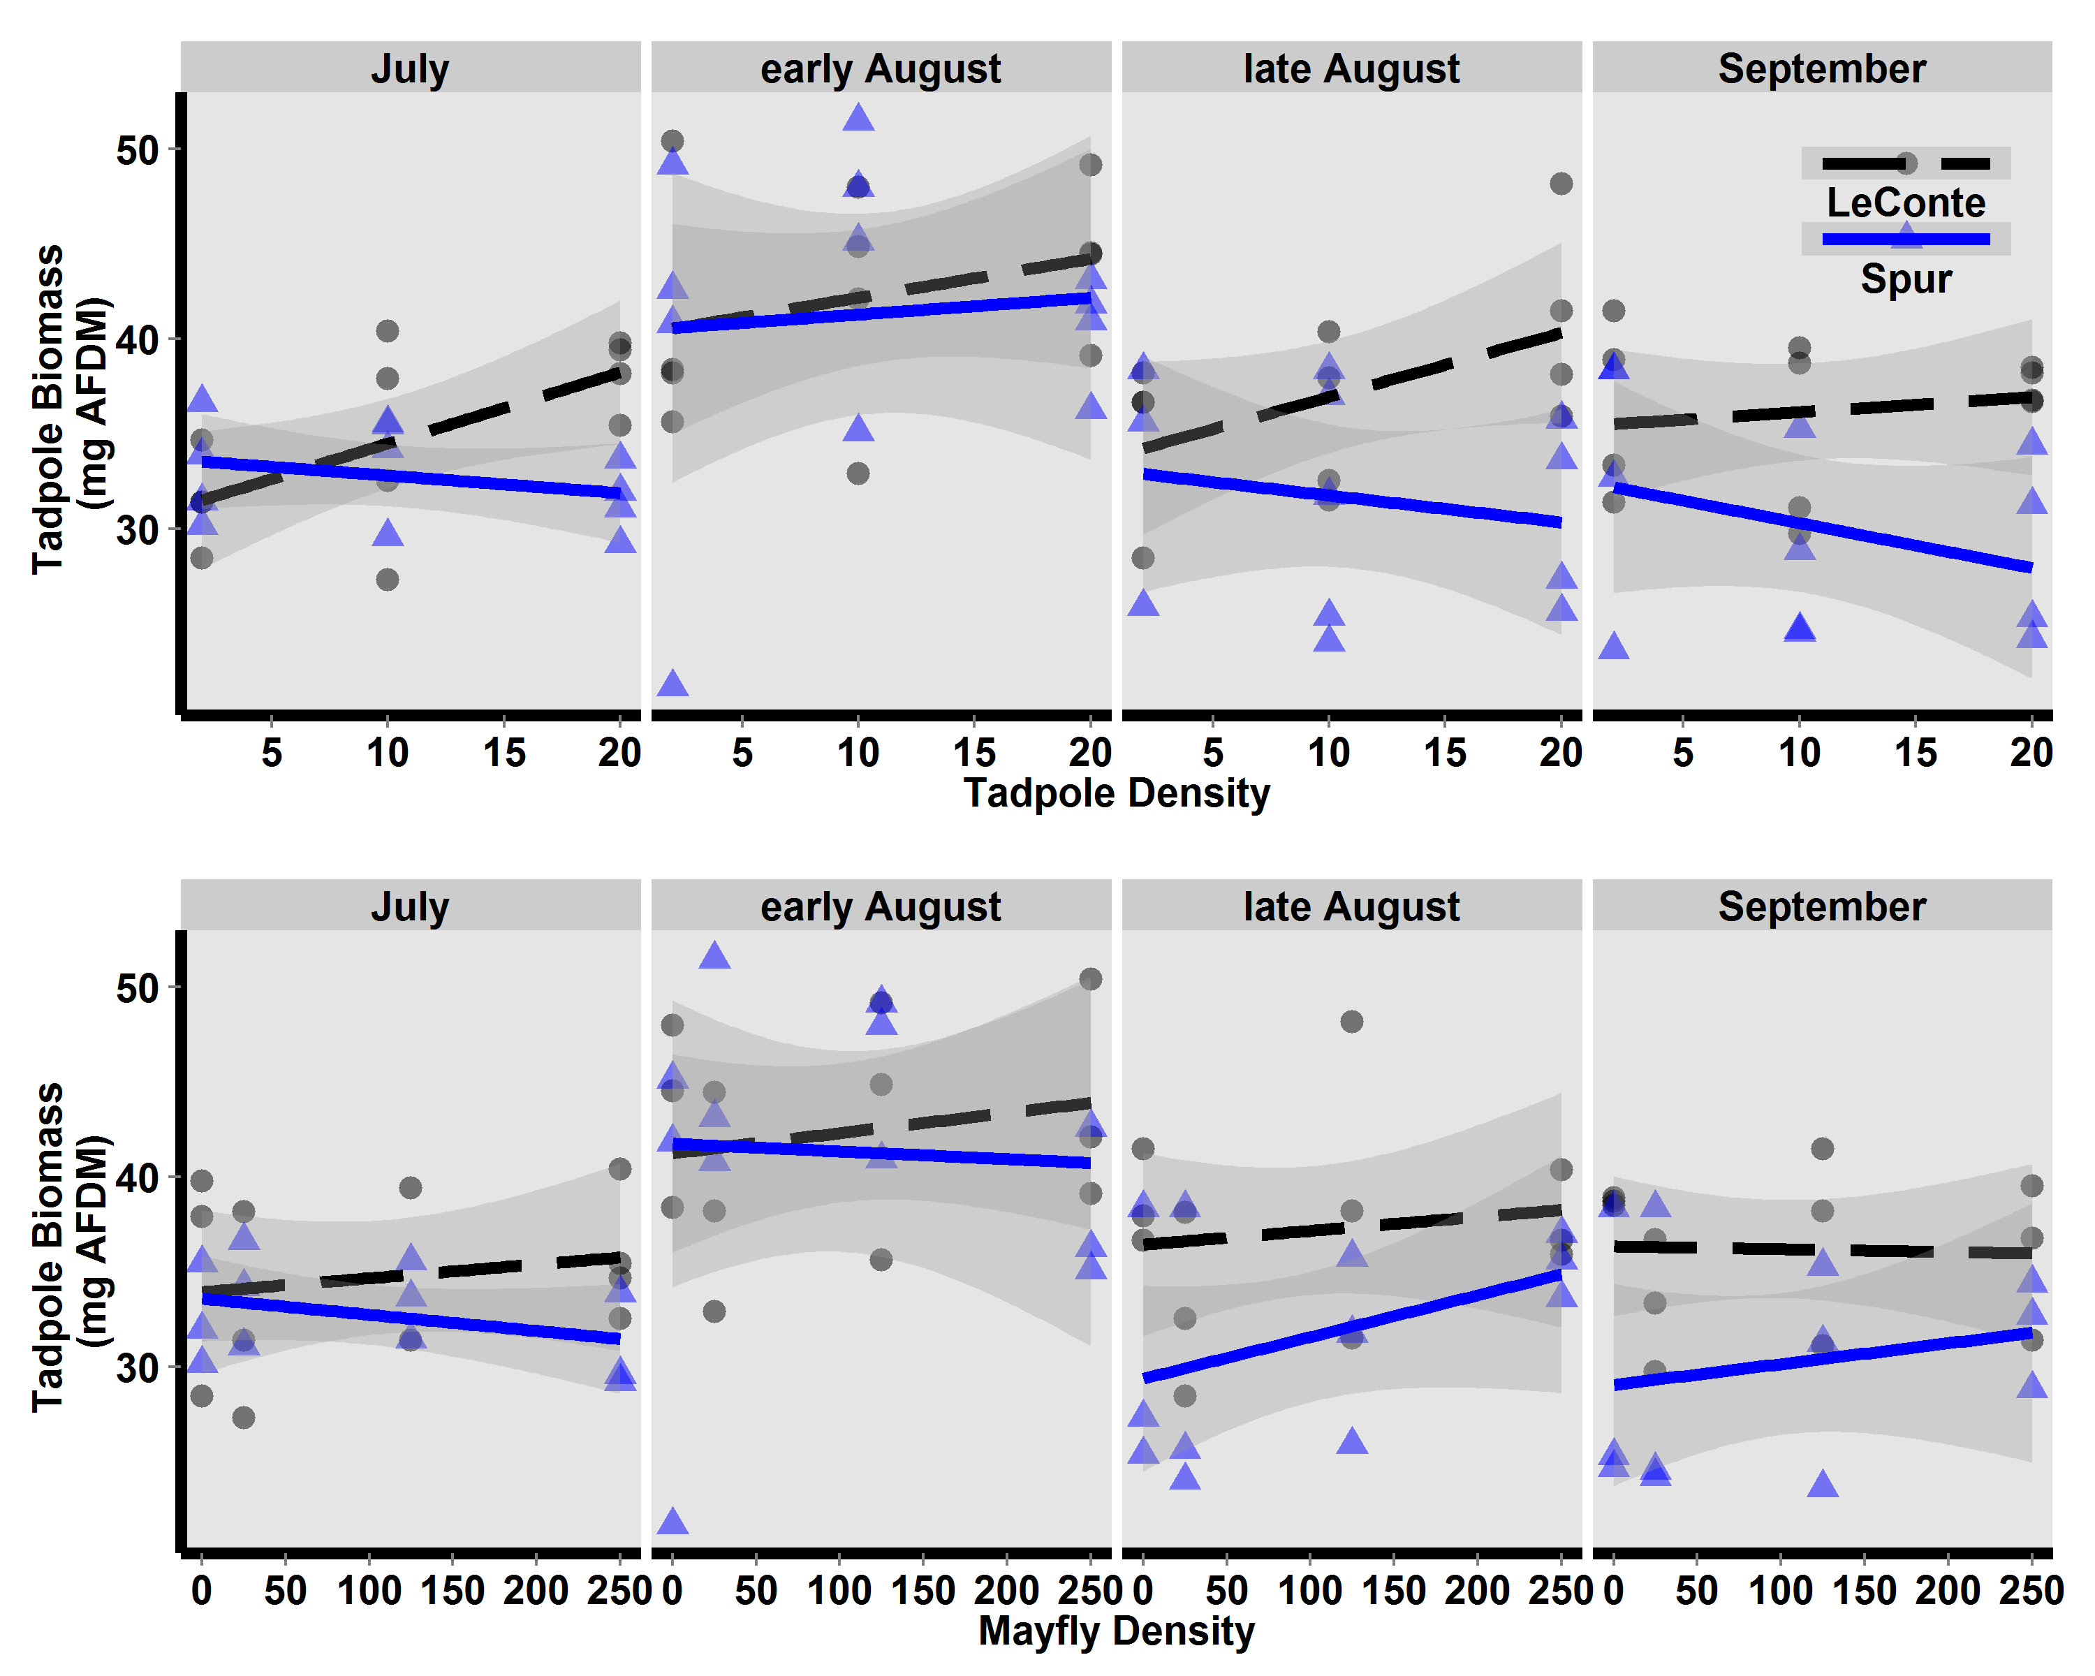

Figure 6. For field enclosures, estimated tadpole AFDM (mg, based on Gosner stage-AFDM regression) with respect to tadpole density (top) and mayfly density (bottom).

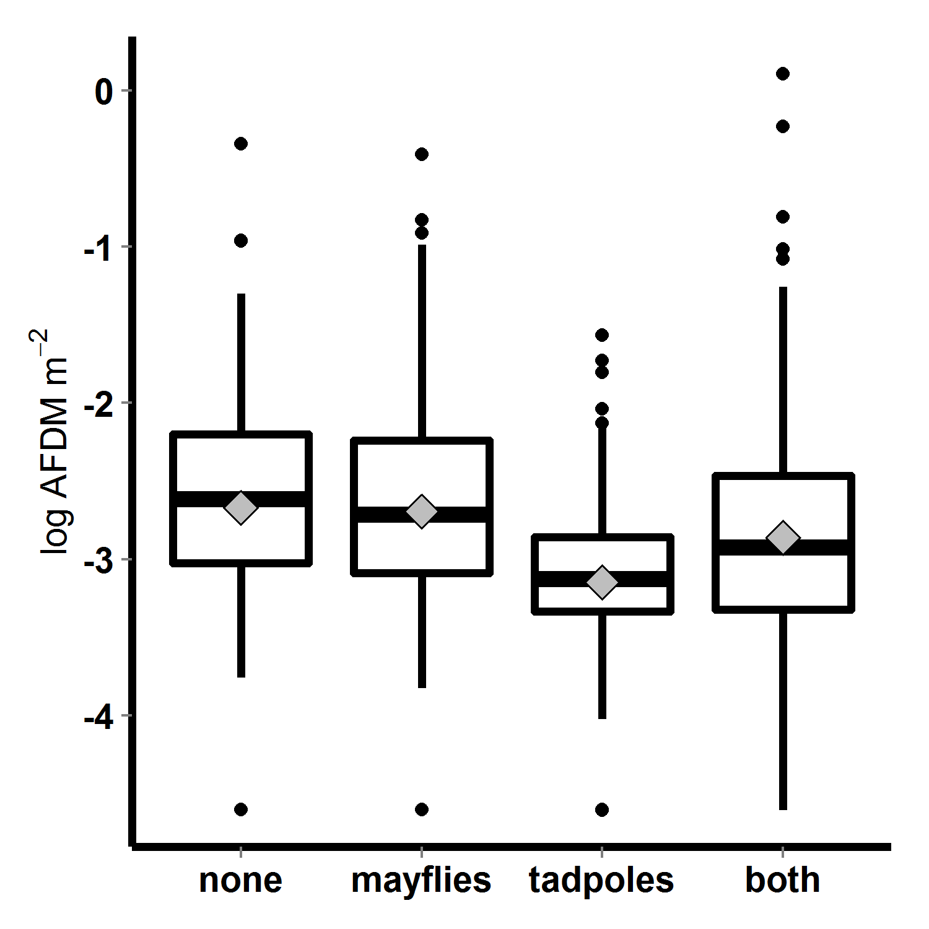

Figure 7. Algal abundance (log transformed AFDM) in 2010 mesocosms, with respect to tadpole and mayfly treatments; bars indicate medians, boxes contain 50% of data, whiskers contain 95% of the data, points are outliers, and diamonds indicate means.

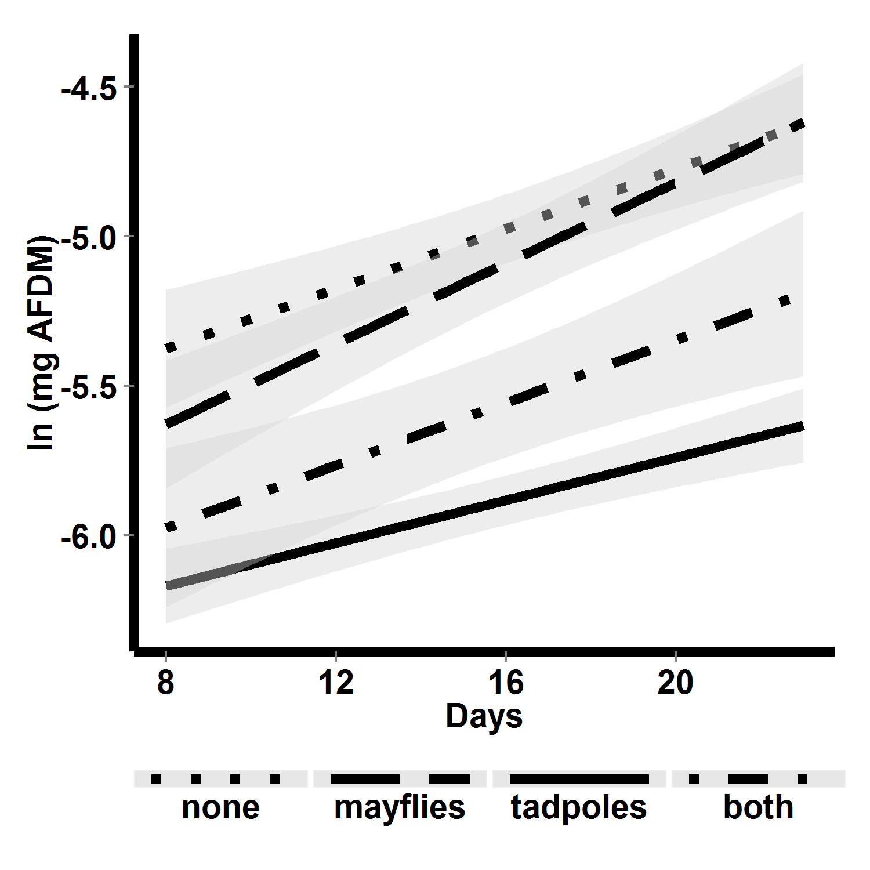

Figure 8. Algal abundance over time in 2010 mesocosms, with respect to consumer treatment. Lines are linear fits, and shaded areas are 95% confidence regions for those fits.

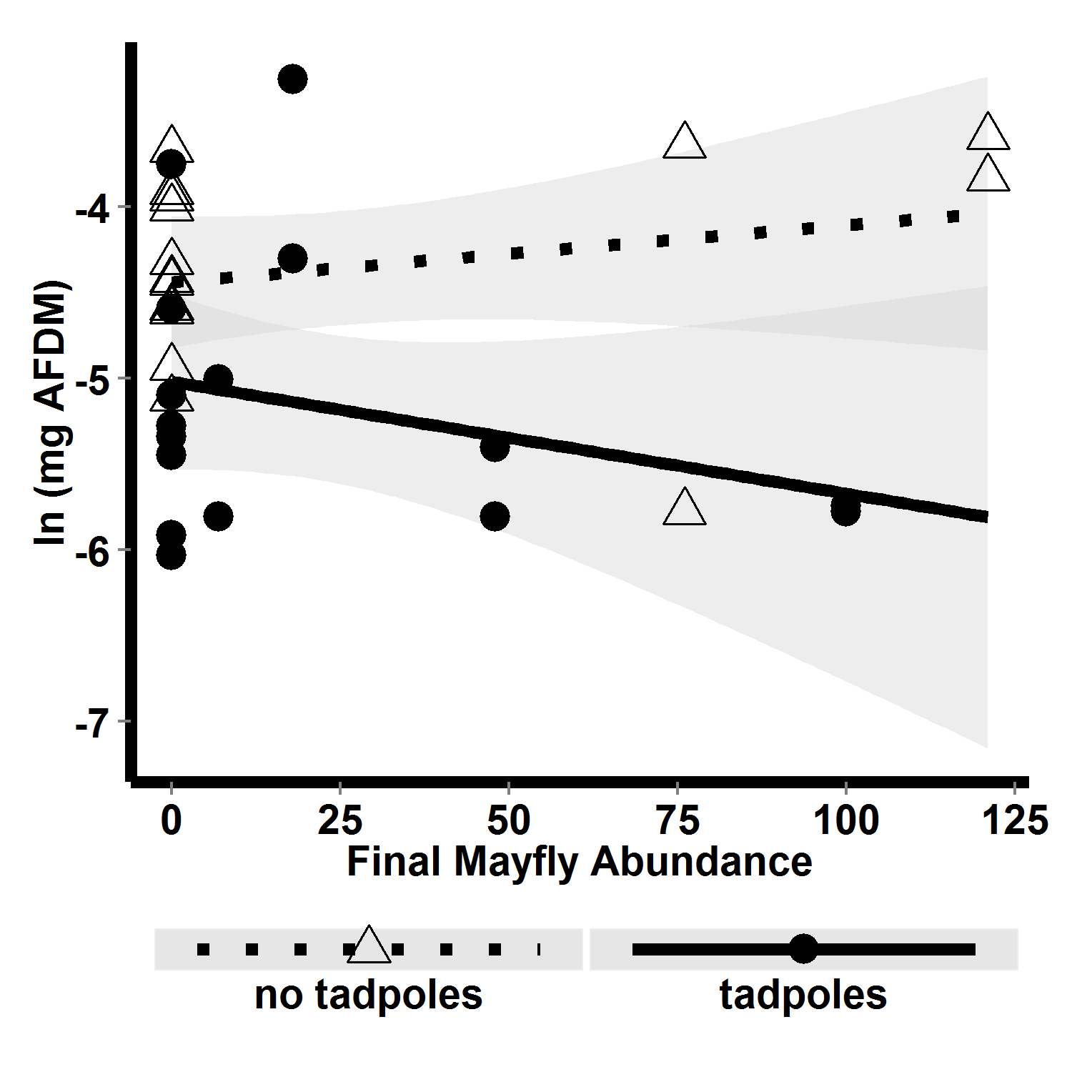

FIG. 7. Algal abundance with respect to interaction between final mayfly abundance and tadpole presence absence.